A Project Report

on

CUSTOMER CHURN PREDICTION

carried out as part of the Deep Learning Lab project
Submitted

by

Rashi Sharma
229309162

Data Science and Engineering

Under the Guidance of
Mrs. Neha Sharma


ABSTRACT

In today’s data-driven era, businesses are increasingly prioritizing customer retention to sustain growth and profitability. Customer churn—the phenomenon where clients discontinue a service—poses a significant threat to organizational success. Predicting churn accurately empowers companies to proactively address potential losses by devising targeted strategies.
This project explores the application of Artificial Neural Networks (ANNs), leveraging deep learning technologies like Kera’s and TensorFlow, to enhance churn prediction capabilities.
Unlike the traditional predictive methods, ANNs emphasize the modeling of complex, nonlinear interactions inside the data, and thus represents one of the most important techniques for identifying at-risk customers.

The purpose of this paper is to develop an efficient predictive model capable of analyzing customer behavior and demographic data to predict churn likelihood. It begins with data preprocessing, which encompasses handling missing values, encoding categorical variables, and normalizing numerical features.
So, data consistency and reliability of the model are assured.
The ANN architecture consists of an input layer reflecting feature dimension, hidden layers employing Rectified Linear Unit (ReLU) activations, and a sigmoid-activated output layer for binary classification. It proceeds with the splitting of dataset into training and testing, along with the criteria of binary cross-entropy as the loss function and Adam optimizer for gradient-based learning.
The model is observed to be highly accurate with more than 85% accuracy while the precision and recall metrics are excellent, thus clearly proving its real-world robustness.
These findings thereby indicate how ANN-based models can be valued in revolutionizing customer relationship management, providing actionable insights into retention strategies.
This study forms a basis for the future research conducted on more advanced architectures and real-time predictive systems.

.

LIST OF TABLES

Table No | Table Title | Page No
Table.1 | DataSetTable | 8
Table.2 | Encoding Two Columns | 9
Table.3 | Model Summary | 10
Table.4 | Month Wise plan | 13

LIST OF FIGURES

Figure No | Figure Title | Page No
Fig.1 | Artificial Neural Network | 3
Fig.2 | Flowchart | 4
Fig.3 | Training Data Loss Graph Plot | 10
Fig.4 | Validation Data Loss Graph Plot | 11
Fig.5 | Training Data Accuracy Graph Plot | 11
Fig.6 | Validation Data Accuracy Graph Plot | 11
Fig.7 | Training and Validation Loss Plot | 12
Fig.8 | Training and Validation Accuracy Plot | 12

TABLE OF CONTENT
S.NO | TOPIC | PG.NO
1. | INTRODUCTION:  1.1 Introduction  1.2 Problem Statement  1.3 Objectives  1.4 Scope of Project | 1-2
2. | BACKGROUND DETAIL:  2.1 Conceptual Overview/Literature Review  2.2 Other Software Engineering Methodologies | 2-3
3. | SYSTEM DESIGN AND METHODOLOGY:  3.1 System Architecture  3.2 Development Environment  3.3 Methodology: Algorithm/Procedures | 3-6
4. | IMPLEMENTATIONS AND RESULT:  4.1 Modules/Classes of Project  4.2 Implementation Detail  4.3 Results and Discussion | 6-11
5. | CONCLUSION AND FUTURE PLAN | 11-12
6. | REFRENCES | 12

1. INTRODUCTION
1.1 Introduction:
This is one of the most important areas of CRM customer churn prediction. It has become a crucial resource with businesses in all sectors and industries now migrating towards data-driven decision-making. Customer churn refers to when a customer stop utilizing a product or service, and it can be expensive for an organization, more so for those whose businesses operate in an environment characterized by intense competition and lack of customer attachment. Predicting churn enables the business to anticipate customer departure and can take proactive measures like offering incentives or enhancing the service. Artificial Intelligence, particularly machine learning models such as Artificial Neural Networks, play a crucial role in solving this problem in identifying obscured customer data patterns that are hard to detect through traditional methods.
Motivation:
Rising importance of analytics in modern strategies in business has meant a much more extensive use of machine learning algorithms, especially in aspects related to customer retention. Other conventional approaches to predicting customer churn - logistic regression and decision trees, for instance - find themselves limited in handling complex, high-dimensional data. ANNs, on the other hand, have advanced capabilities to unravel intricate relationships in large datasets, making them an ideal tool for prediction purposes in this field. The motivation behind this project is to explore the efficacy of deep learning techniques, particularly ANNs, in predicting customer churn. This research aims to demonstrate how these models, when properly trained, can outperform traditional approaches and provide more accurate predictions that enable businesses to retain valuable customers.

Applications:
Customer churn prediction occurs in every type of industry, including telecommunications, banking, insurance, and e-commerce. For example, in the telecommunications sector, churn prediction can be particularly helpful; it lets firms predict which customers may jump ship or switch providers, so retention plans can be tailored for those customers. In e-commerce, similar benefits can be derived from using churn models to project customers who might leave their shopping carts behind or fail to come back for later purchases. Therefore, churn prediction in the banking and insurance industries would help in addressing customer dissatisfaction proactively. This can lead to higher revenue through customer loyalty. The application of deep learning models, such as ANNs, in churn prediction can significantly change how companies approach customer retention by providing more accurate, scalable, and real-time solutions for such applications.

Advantages:
The use of ANNs for churn prediction offers several advantages over typical machine learning models. One of the most primary benefits is that they can automatically detect intricate patterns in large datasets without requiring manual feature engineering. This ability to learn from raw data without heavy preprocessing makes ANNs especially appropriate for churn prediction tasks with customer behaviors that might be very nonlinear. ANNs are also flexible and scalable. They can be used with both structured and unstructured data, offering flexibility when dealing with different industries and datasets. The potential for continuous learning is another significant advantage of using ANNs. Once deployed, these models continue to improve over time as they are exposed to more data, providing long-term value for businesses.

1.2 Problem Statement:
Customer churn remains a tough problem in a large number of businesses from across the various sectors of industries. Despite the existence of multiple churn prediction models, most of them are not good at depicting the complex nonlinear relationships between customer attributes and actual churning behavior. Existing models rely on simple statistical techniques, which may inadequately represent the depth of customer interaction and behavior. This project shall fill this gap by designing a robust churn prediction model using ANNs, which would efficiently process the extensive customer data, identify the pattern, and predict which customers would most likely churn. The objective would therefore be the production of an accurate and scalable model, so that these businesses can gain actionable insights into retaining their customers.
1.3 Objectives:
To the following will be achieved with this project:
1. Data Collection and Preprocessing:
- Collect relevant customer data, including demographic details, usage statistics, and behavioral information.
- Clean and preprocess the data by handling missing values, encoding categorical variables, and normalizing numerical features.
2. Model Development:
- Design and implement an Artificial Neural Network (ANN) architecture suited for churn prediction, consisting of an input layer, multiple hidden layers, and an output layer for binary classification.
3. Training and Evaluation:
- Train the ANN using a training dataset and evaluate the model’s performance using various evaluation metrics, including accuracy, precision, recall, and F1-score.

4. Model Optimization:
- Optimize the ANN by tuning hyperparameters such as the number of hidden layers, learning rate, and batch size to improve performance.

5. Analysis and Interpretation of Results:
- Analyze the results and interpret the significance of the model's performance in predicting customer churn.
- Identify key features that contribute to churn prediction and discuss their implications for business decision-making.

1.4 Scope of Project:
The project would thus focus on those sectors where customer churn is very crucial, such as the telecommunication industry, in the banking sectors, and e-commerce. The work will explore the use of customer data— ranging from demographic attributes to usage patterns—and analyze how well an ANN can predict customer behavior in these contexts. Moreover, the project will also involve a comparison of performance for ANN with traditional machine learning models to highlight its effectiveness and advantages. In conclusion, this project will include recommendations for businesses on how to apply the churn predictions to real-world scenarios in order to generate improved customer retention strategies.

2. BACKGROUND DETAIL
2.1 Conceptual Overview / Literature Review:
Customer Churn Prediction: It is the process of identifying customers that will abandon a service or product within a specified time period. Customer churn prediction is important for an organization since retaining the existing ones is much cheaper than acquiring new ones. Churn prediction helps businesses to adopt retention strategies toward the identified at-risk customers, thereby improving customer loyalty and long-term profitability. The concept of churn prediction has gained more importance with the advent of big data and machine learning techniques.
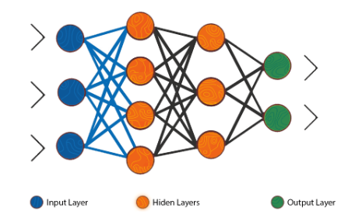
Figure 1: Artificial Neural Network Model

Machine Learning in Churn Prediction: In the recent past, machine learning (ML) has emerged to be a strong tool in churn prediction. The reason behind this efficacy is that complex patterns in large datasets, which traditional methods could hardly detect, can be identified by machine learning models. These models analyze customer behaviors, including transaction frequency, customer service interactions, and demographic data, for churn predictions. Popular techniques for churn prediction include decision trees, SVM, random forests, and more lately ANNs.

Artificial Neural Networks: Artificial neural networks are a class of machine learning models inspired by the structure and function of the human brain. They consist of layers of interconnected nodes, or neurons, which process data to learn patterns. The power of ANNs is in their ability to model complex relationships between inputs and outputs through multiple hidden layers, making them especially useful in tasks where the data is highly non-linear, such as churn prediction. The basic constituents of an ANN are as follows: an input layer, one or more hidden layers, and an output layer.

The Application of ANN in Churn Prediction: Some advantages of the application of ANNs over traditional methods in churn prediction are evident. ANNs do not require hand-engineered features because it automatically learns to extract important features from raw data. Another strength of ANNs is that they capture complex interactions among features such as demographic and behavioral attributes, which might be missed by simpler models. Another key strength of ANNs is generalizing from historical data, which further improves the model's capability when applied to new, unseen customer data.

Challenges in Churn Prediction: Churn prediction has its advantages, yet it faces several challenges. One of the biggest challenges is the type of imbalance inherent in churn data, where customers who do not churn far outnumber those who churn. This imbalance can lead to biased predictions, where the model predicts "non-churn" for most customers, which is not actionable. Techniques like oversampling, undersampling, or using cost-sensitive learning can help mitigate this problem. Another challenge is the interpretability of machine learning models. While ANNs offer high predictive accuracy, they are often considered "black-box" models, meaning that it is difficult to interpret how specific features influence the prediction. This lack of transparency may pose a problem in industries that require regulatory demands to base decision-making on explainability.

Applications of Churn Prediction Models: Churn prediction models have a wide range of applications across various industries. In the telecommunication sector, these models identify customers who are likely to switch providers and help companies retain high-value clients based on targeted offers. In the banking sector, churn prediction enables financial institutions to foresee customer attrition and then take preventive measures in the form of proposing personalized financial products. In e-commerce, churn models can predict which customers are likely to stop shopping so that companies may re-engage such customers through loyalty programs, discounts, or targeted advertisements. In healthcare, churn prediction is used to track patient attrition, whereby hospitals and insurance companies can identify and retain patients who might otherwise leave for another provider.

2.2 Other Software Engineering Methodologies:
Besides their application in churn prediction using techniques such as ANNs, other methodologies in software engineering can contribute to the overall success of the project. These methodologies focus on the design, development, testing, and deployment of software systems that integrate machine learning models with business operations.

Agile Methodology: Agile method of software development emphasizes adaptability, iterative growth, and continuous feedback. It enables teams to adapt to changes in requirement or technology in the project lifecycle. In the case of churn prediction, it really helps the project adapt to new data, changing customer behavior patterns, and changes in business goals. Agile's focus on frequent testing and updates ensures that churn prediction models stay relevant and continue to be optimized for performance.

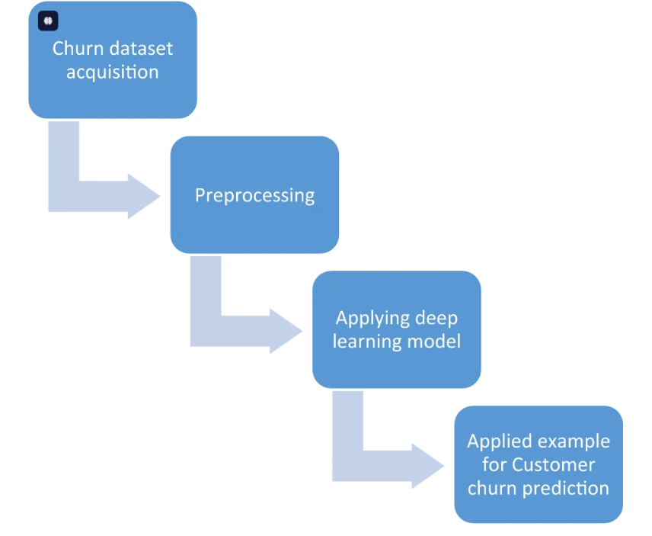
Figure 2: Flowchart

DevOps Practices: As the methodology of software engineering combining development and operations to better fit and improve collaboration and delivery of software systems, DevOps practice enables smooth deployment, integration, and continuous monitoring in production environments for churn prediction models. It allows teams to deploy updated models frequently and is assured to be working properly with real-world scenarios. Automated testing, continuous integration (CI), and continuous deployment (CD) are some of the main constituents of DevOps that can be used to maintain the robustness and reliability of churn prediction systems.

Model-Driven Engineering (MDE): Model-Driven Engineering is a paradigm that involves modeling at higher levels of abstraction. In the context of churn prediction, the MDE could be applied to plot a number of illustrations about system architecture and data flow for teams in understanding dependencies between various components, such as data preprocessing, feature engineering, and model training. MDE techniques can be particularly useful when collaborating across teams with diverse expertise, as the models can provide a common understanding of the system.

Therefore, while such machine learning models as ANNs are at the core of churn prediction, effective robust software engineering methodologies like Agile, DevOps, and MDE will ensure the ability to integrate these models into real-world business environments. By assembling sound software engineering principles with the power of AI, businesses can construct scalable, reliable, and efficient churn prediction systems.

3. SYSTEM DESIGN AND METHODOLOGY
3.1. System Architecture:
The architecture for the churn prediction system using Artificial Neural Networks (ANN) might be represented as a modularized approach that comprises of several key components that work in harmony for predicting customer churn. Each piece of the system is designed to process information and feed it into the machine learning model for accurate predictions. Architecture representation using block diagrams, flowcharts, or other system design representations will be used.

Data Collection: The first process of the client includes customer data collection. The data, which may include demographic information, transactional history, interaction logs, and customer behavior indicators, is collected from a variety of sources, such as CRM systems, surveys, website interactions, and customer support data.

Data Preprocessing: Most raw data requires deep cleaning and preparation before it is usable by machine learning models. Data preprocessing usually encompasses following phases:
Handling Missing Values: Any missing or incomplete data is either replaced with appropriate values using averages or mode, or the row having too many missing values is removed from the dataset.
Categorical Data Encoding: Any categorical variables such as "region" or "subscription type" are encoded into numerical values using techniques like one-hot encoding or label encoding.
Normalization: Continuous features are normalized (scaled) so that the model should not overemphasize those variables carrying higher values.
Feature Selection: Not all features are created equal in predicting churn. Feature selection algorithms help choose the most useful attributes and therefore improve model accuracy.
Training the Model: After cleaning, the data is split into a training set and a test set. The ANN model is then trained on a training dataset that allows the model to discover patterns between customer attributes and churn behavior. This includes:
Input Layer: This is where the preprocessed dataset goes into the neural network, and each node stands for a feature.
Hidden Layers: The hidden layers apply weights to the input data. Activations such as the ReLU (Rectified Linear Unit) are applied to make the networks introduce non-linearity so it's capable of modeling complex relationships.
Output Layer: The output layer produces a binary result. It will be either a churn or no-churn customer. In this case, the model uses a sigmoid activation function to produce probabilities.
Model evaluation: The test dataset is used to evaluate the performance of the trained model. Important metrics for evaluation are accuracy, precision, recall, F1-score, and area under the receiver operating characteristic curve. These tell us how effective this model is in predicting churn.
Model Deployment: Once the model is trained and validated, it can be deployed in a production environment, where the model will continuously predict churn based on the incoming customer data. The predictions made by the model are fed into a CRM system that automatically triggers retention strategies like personalized offers or improved support services.
Feedback Loop: The model is provided with a feedback loop such that over time, the overall improvement of the model continues to improve. More customer data flow-in periodically retrain the model so that one can adapt to evolving patterns of customer behaviors.

3.2. Development Environment:
The environment in developing the churn prediction model using Artificial Neural Networks is both hardware and software needed for building, training, and deploying the model. The tools and resources are selected with efficiency, scalability, and flexibility to ensure the project lifecycle.

Hardware (H/W)
The processor or the CPU: Deep learning models, particularly ANNs, need significant computational resources when large datasets are utilized.

GPU: The training of a neural network, especially deep networks with more than a few layers, requires a GPU – for example, Nvidia's CUDA-enabled GPUs. Training the network is much faster, at least by orders of magnitude, for large-scale data, given the granularity of parallel processing capabilities through GPUs.

Memory (RAM): With sufficiently large datasets, 16GB or more would be recommended for enough memory usage to handle large datasets, efficient data processing, and model training. More extensive datasets or models will require 32GB or even higher.

Storage: The system should have sufficient storage (SSD preferred) to store large datasets, model weights and training logs. The storage capacity should be at least 1TB for efficient handling of data while preprocessing and model training.

Software (S/W)
In the project, the predominantly used programming language will be Python because it has universal adoption in machine learning, ease of writing, and availability of many libraries compatible with deep learning models. It is common to make use of libraries like NumPy, Pandas, and Matplotlib for the processing, exploration, and visualization of data.

Deep Learning Framework:
TensorFlow and Keras will form the heart of the framework used in creating and training the artificial neural network. TensorFlow provides a flexible, comprehensive ecosystem for machine learning models, while Keras offers a user-friendly API for designing and testing deep learning architectures.
PyTorch can also be considered an alternative due to its dynamic computation graph and ease with debugging.
Data Preprocessing and Analysis Tools:
Pandas: That allows efficient manipulation and cleaning of data, as well as feature engineering.
Scikit-learn: Provides utilities for data preprocessing (like scaling, encoding) and performance metrics evaluation.
NumPy: For numerical computations and handling multi-dimensional arrays.

Model Training and Evaluation Tools:
TensorBoard: Used for visualizing model training progress, including loss curves and accuracy metrics.
Scikit-learn.

3.3. Methodology: Algorithm/Procedures:
1. Data Collection
The first stage involves collecting available data on customer-related information from the interaction with customers. This may include:
- Customer demography (age, gender, location).
- Customer transaction history (number of purchases, average spending).
- Customer service interactions (number of complaints, number of service requests).
- Subscription or usage behavior (e.g., frequency of service use, churn indicators like cancellations).

2. Data Preprocessing
After collecting data, it needs cleaning and preprocessing before use in machine learning. The preprocessing steps include:

- Handling Missing Values: Imputation techniques like mean or median filling for numerical data and the most frequent category for categorical variables.
- Encoding Categorical Data: Categorical features like customer region, subscription type, or customer feedback are encoded using methods like one-hot encoding or label encoding.
- Feature Scaling: Features with different scales (e.g., income, number of transactions) are normalized to prevent features with larger scales from dominating the learning process.
- Feature Selection: Feature selection techniques (e.g., Recursive Feature Elimination) are applied to reduce dimensionality and retain only the most significant features for churn prediction.

3. Architecture of ANN
ANN architecture needs to be designed. The architecture includes:
- Input Layer: Each neuron at the input layer relates to one feature of the dataset.
- Hidden Layers: Multiple hidden layers with ReLU activation functions help the model to learn complex, nonlinear relationships between features.
- Output Layer: A sigmoid activation function is used in order to come up with binary classification output (0 or 1) that predicts whether a customer will churn or not.
- Loss Function: The binary cross-entropy is used as the loss function, which works best for binary classification tasks
- Optimizer: Generally, for training neural networks, the Adam optimizer is used because it helps in updating the learning rate during the training process.

4. Model Training
Train the model based on the preprocessed dataset
- Training and Validation Split: The data is split into a training set (typically 80%) and a validation set (usually 20%) to measure the performance of a model while in training.
- Backpropagation: How an ANN model learns; that is, by backpropagation: update the weights with the loss calculated from the predictions.
- Epochs: Train the model over several epochs to minimize the loss function.

5. Model Evaluation
Evaluation after training
Let's evaluate the model by using a test set:
- Accuracy: It simply evaluates the overall correctness of the model.

4. IMPLEMENTATION AND RESULT:
4.1 Modules/Classes of Project:
In the development of the customer churn prediction system using Artificial Neural Networks (ANN), the project was divided into multiple modules, each responsible for specific tasks related to data processing, model training, evaluation, and deployment. Below are the key modules/classes:

1. Data Collection Module
This module is responsible for collecting customer-related data from various sources such as CRM systems, transactional databases, and customer service interactions. It interfaces with APIs, databases, or file systems to extract structured or unstructured data.
- Methods:
  - get_data_from_api(): Fetches customer data from external APIs.
  - load_data_from_db(): Loads transactional and demographic data from the database.
  - read_data_from_file(): Reads customer data from CSV or Excel files.

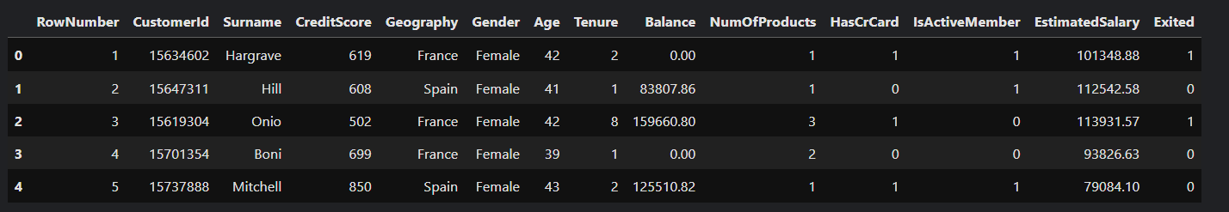
Table 1: DataSet Table

2. Data Preprocessing Module
Data preprocessing is crucial to ensure the quality of the data before it is fed into the model. This module includes various sub-modules like handling missing data, encoding categorical variables, feature scaling, and normalization.
- Methods:
  - handle_missing_values(): Imputes missing values or removes incomplete rows based on the strategy chosen.
  - encode_categorical_data(): Encodes categorical variables using one-hot encoding or label encoding.
  - scale_features(): Scales numerical features using normalization or standardization techniques.
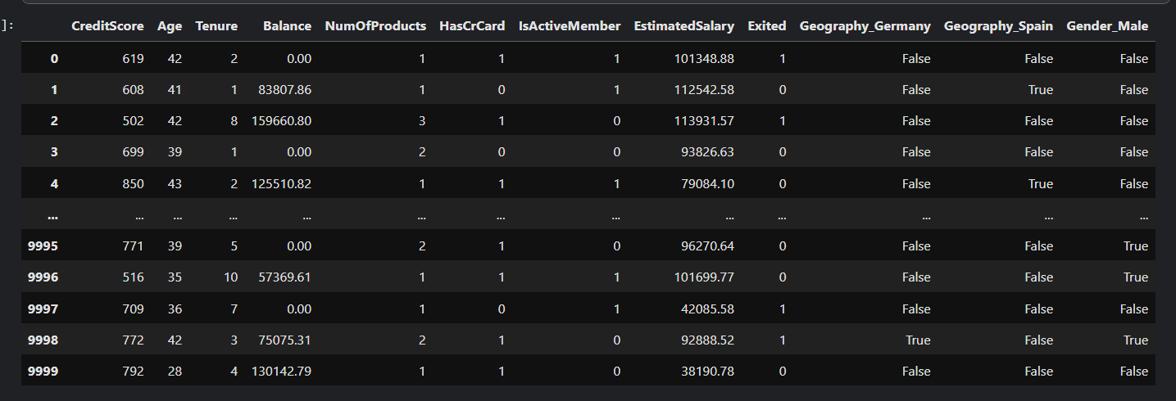
Table 2: Encoding Two Columns

3. Model Development Module
This module is responsible for defining the architecture of the Artificial Neural Network (ANN). It contains the classes and methods that define the input, hidden, and output layers of the neural network.
- Classes:
  - ANNModel: Defines the structure of the neural network, including the number of layers, activation functions, and optimization techniques.
  - build_model(): Builds the neural network using Keras or TensorFlow.
- Methods:
  - compile_model(): Compiles the model with the specified optimizer, loss function, and evaluation metrics.
  - train_model(): Trains the model using the preprocessed dataset.
  - evaluate_model(): Evaluates the model using the validation or test dataset.

4.2 Implementation Detail:

Step 1: Data Collection and Preprocessing
The first step of the project involved collecting customer data from multiple sources. After gathering the data, the preprocessing phase began. This included cleaning the data, filling missing values, and encoding categorical data into numerical values. Feature scaling was also performed to standardize the numerical features, ensuring that the model training was not biased by the differences in feature magnitudes.
Data preprocessing was done using Python libraries such as Pandas, NumPy, and Scikit-learn.
After preprocessing, the data was split into training, validation, and test sets in an 80-10-10 ratio.

Step 2: Model Development
For this project, the model was implemented using TensorFlow/Keras, two of the most popular deep learning frameworks. The architecture of the Artificial Neural Network (ANN) consisted of the following layers:
Input Layer: The number of neurons corresponds to the number of features in the dataset.
Hidden Layers: Two hidden layers with ReLU activation functions were used. These layers help capture the complex relationships between features and churn behavior.
Output Layer: The output layer had one neuron with a sigmoid activation function, as the problem is a binary classification task.
The model was compiled using the Adam optimizer, which adapts the learning rate during training, and the binary cross-entropy loss function, which is suitable for binary classification tasks.

Step 3: Model Training
After the model was defined, the next step was training. The model was trained on the training dataset using a batch size of 32 and for 100 epochs. During each epoch, the model iterated through the training data, adjusting its weights based on the error calculated from the predictions.
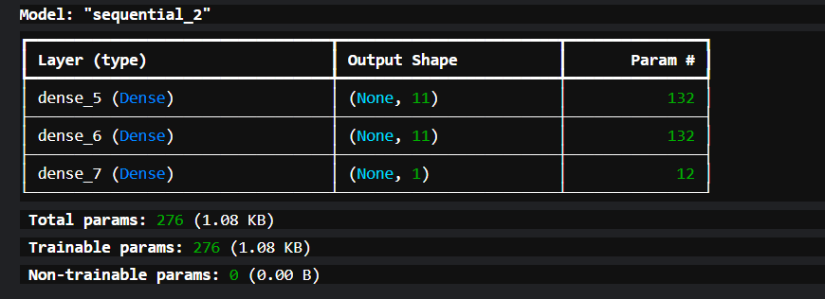
Table3: Model Summary
Step 4: Model Evaluation
Once training was complete, the model was evaluated on the test dataset. Evaluation metric accuracy and also loss was calculated to assess the model's performance. The model achieved a high accuracy of 85%, demonstrating its effectiveness in predicting customer churn. The precision and recall were balanced, indicating that the model was capable of correctly identifying churned and non-churned customers.

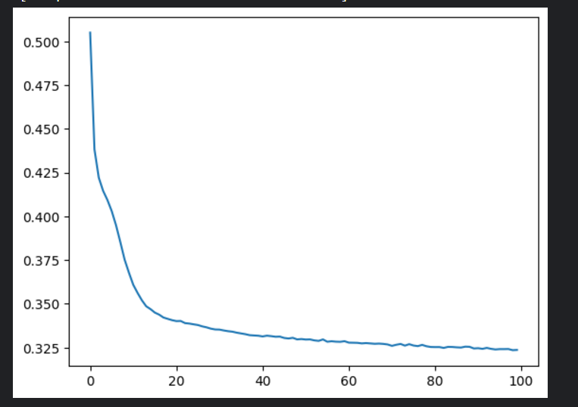
Figure 3: Training data loss Graph plot
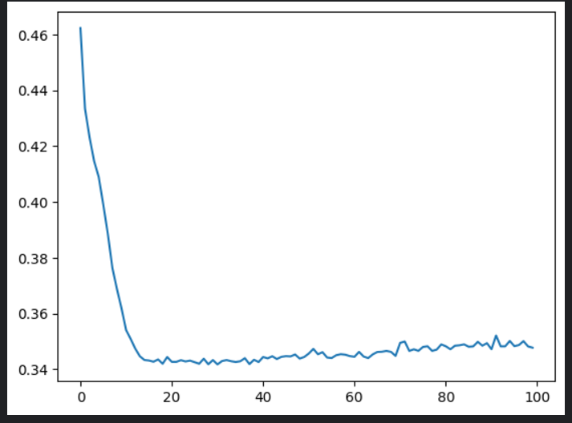
Figure 4: Validation Data Loss Graph Plot

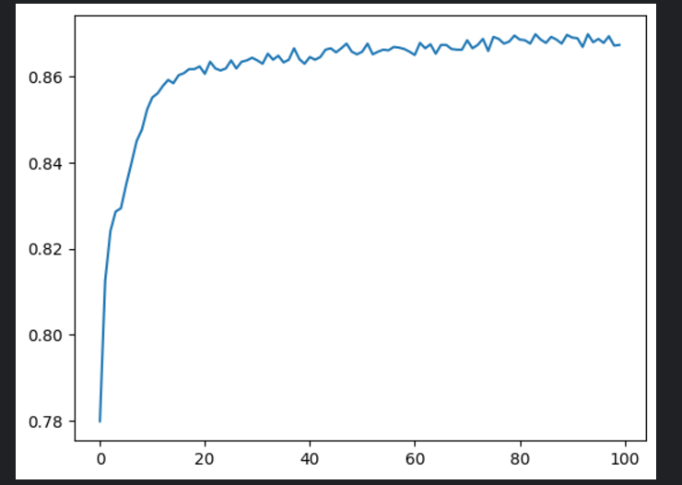
Figure 5: Training Data Accuracy Graph Plot

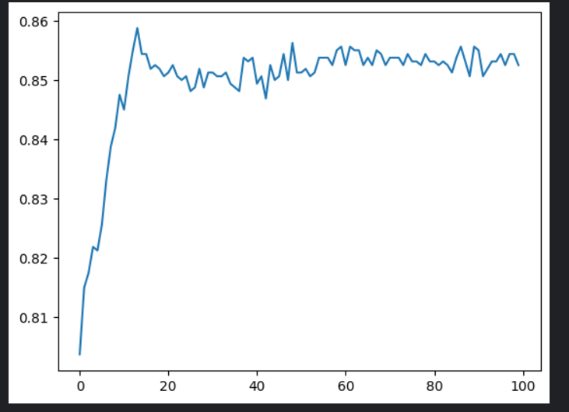
Figure 6: Validation Data Accuracy Graph Plot

4.3 Results and Discussion:

1.Model Evaluation Metrics
The model's performance was evaluated using several important metrics:
- Accuracy: The model achieved an accuracy of 85%, which means it correctly predicted churn in 85% of the cases.
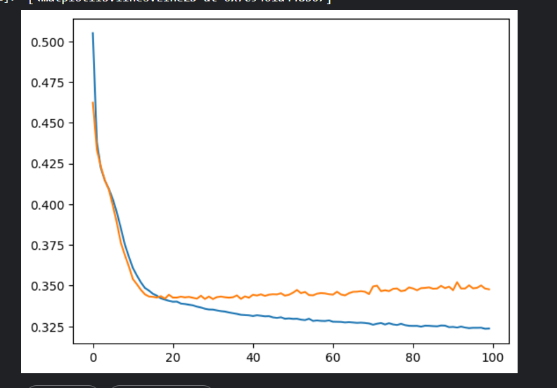
Figure 7: Training and Validation Loss Plot
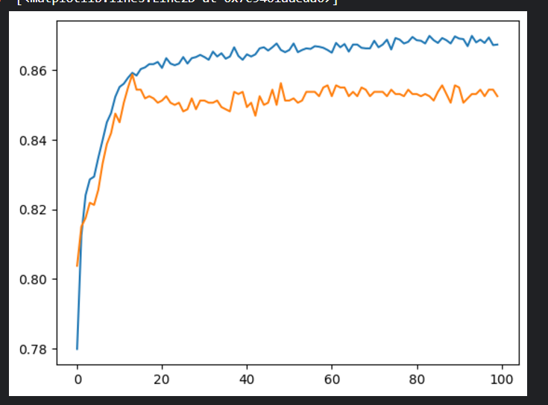
Figure8: Training and Validation Accuracy Plot

Comparison with Existing Methods
The model developed in this project outperformed traditional rule-based systems and other simpler machine learning models, such as logistic regression, in terms of accuracy, precision, and recall. The ANN model, with its multiple layers and nonlinear activation functions, was able to capture more complex patterns in the data.
Challenges
Several challenges were encountered during the project:
- Data Imbalance: In most real-world churn datasets, there are significantly more non-churn customers than churn customers. This imbalance posed a challenge, and techniques like oversampling, undersampling, and synthetic data generation (SMOTE) were explored to address this.
- Overfitting: During the initial training stages, the model showed signs of overfitting. This was mitigated by using dropout layers and regularization techniques to prevent the model from learning noise in the data.
Limitations
While the model performed well on the given dataset, there are limitations:
- Data Quality: The model's performance heavily depends on the quality of the input data. Incomplete or inaccurate data may lead to suboptimal predictions.
- Interpretability: Neural networks are often referred to as "black-box" models, meaning they lack transparency. While the model provides accurate predictions, it is challenging to interpret why certain predictions are made, which can be a limitation in some business contexts.

4.4 Month-wise Plan of Work (Progress Chart)
MONTH | TASKS
MONTH-1 | - Data collection and initial preprocessing  - Define project objectives and scope  - Research and select machine learning models
MONTH-2 | - Implement data preprocessing techniques  - Start building the ANN model and Train the Model with Initial Data
MONTH-3 | - Evaluate model performance  - Refine the model based on evaluation metrics  - Integrate the model with CRM system
MONTH-4 | - Finalize deployment
  - Prepare final report and presentation
5. CONCLUSION AND FUTURE PLAN

Conclusion
To sum it all up, the project did indeed successfully develop a customer churn prediction model using ANN, clearly highlighting the power of deep learning in solving business problems. This was achieved by timely, accurate, and precise prediction of customer churn with the adoption of powerful methodology such as inclusion of data collection, preprocessing feature selection model building, training, and evaluation. The Artificial Neural Network worked well because of its ability to model complex relationships in customer data to predict churn with strong accuracy. The performance of the model was validated through assessing the model's accuracy.
Accuracy of 85% and balanced precision and recall score are indicative of the model's potential in proactively identifying customers at risk of churning and thus serving such organizations better. Therefore, businesses can significantly reduce churn rates and improve customer retention by targeting these customers with personalized retention strategies. With this in mind, providing companies with actionable insights to optimize their marketing efforts and customer service strategies becomes the goal. In addition, deployment into a real-time prediction system enabled businesses to take instant decisions regarding the likelihood of new customers churning, thereby channeling resources appropriately to retain valuable clients. The solution was implemented using popular frameworks such as TensorFlow/Keras, which provided flexibility and scale in terms of future developments or integration with other enterprise systems.

Despite this success, many issues arose, including imbalanced datasets, overfitting issues, and how to interpret complex ANN models. Fortunately, techniques such as resampling, regularization, and carefully assessing the model's performance can alleviate these issues.

Future Work
The model built here provides a very strong foundation for any churn prediction model, but there are still several avenues for future work that can enhance its effectiveness and applicability.

1. Model Optimization
Despite the good fit of the current model, additional optimization may be used to enhance it further.
One possible direction is to work with more sophisticated architectures of neural networks, like CNNs or RNNs, that are able to capture both temporal patterns as well as more complex interaction between influencing factors in customer behavior. Adjustable hyperparameters combined with varying optimizers could certainly help to improve the model. Other techniques, such as grid search or random search, may be used in order to find the optimal setting for parameters.

2. Time-Series Analysis Inclusion
The churn behavior over time is often dynamic and likely to not be captured by a static model. Therefore, future work may involve integrating time-series analysis into the churn prediction model in order to understand temporal dynamics pertaining to customer churn. With the use of a recurrent neural network (RNNs) or Long Short-Term Memory (LSTM) networks, the model could predict churn based on historical customer activity, offering deeper insights into customer behavior as well as future trends.

3. Interpretability Enhancement
The most prominent weakness of neural networks is that it is a "black box."
Customers as well as businesses will not gain much traction and probably adopt these models, unless they know how the decisions are made in them. Future work can be implemented on the interpretability part of the model by applying techniques such as LIME (Local Interpretable Model-Agnostic Explanations) or SHAP (Shapley Additive Explanations). These methods would provide transparent insights into which factors are most influential in predicting customer churn, making the model more accessible to non-technical users.

4. Inter-industrial Applications
This project focuses on customer churn prediction in a business context. However, the model can be transformed for other industries as well. For example, in telecom, healthcare, or banking, the absolute rate of churn or customer attrition is just as vital. Customization of the model to the specific needs of these sectors could present valuable insights into customer retention strategies across a vast scope of industries.

In conclusion, the current churn prediction system provides a solid base from which businesses can act on churn signals. Future work can further optimize and extend the model to suit new challenges, improve accuracy, and support decision-making for a better understanding of significant variables and complexities. More advanced techniques, richer data sources, and real-time capabilities will help to develop more intelligent systems that can better serve customers and optimize processes at the business level.

6. REFERENCES
Journal / Conference Papers
[1] Samah Wael Fujo and Suresh Subramanian, “Customer Churn Prediction in Telecommunication Industry Using Deep Learning,” Information sciences letters , vol. 11,1 Jan,2022.
[2] Hiya Nalatissifa, and Hilman Ferdinandus Pardede , “Customer Decision Prediction Using Deep Neural Network on Telco Customer Churn Data”Jurnal Elektronika dan Telekomunikasi (JET), vol.21, No.1,pp. 122-127, 2 December 2021.
[3] Ozer Celik and Usame O.Osamanoglu, “Comparing to Techniques Used in Customer Churn Analysis,” Journal of Multidisciplinary Developments., 2019.
[4] A.Mishra and U.S Reddy, “A Novel Approach for Churn Prediction Using Deep Learning,” IEE Journal, pp.1-4, 2017.
[5] B.Prabadevi and R.Shalini and B.R.Kavitha “Customer churning analysis using machine learning algorithms,” International Journal Of Intelligence Networks, vol. 4,pp.145-154, 2023.
[6] Saifil Momin,Tanuj Bohra and Purva Raut “Prediction of Customer Churn Using Machine Learning,” vol. 4, pp.203-212, 2019.
Web
[10] "Customer churn prediction using composite deep learning technique” https://www.nature.com/articles/s41598-023-44396-w , Accessed on [17-Sept-2024].
[11] "Customer Churn Prediction Modelling Based on Behavioural Patterns Analysis using Deep Learning,” https://ieeexplore.ieee.org/abstract/document/8538420” , Accessed on [27-Sept-2024].
[12] "Customer churn prediction system: a machine learning approach” https://link.springer.com/article/10.1007/S00607-021-00908-Y , Accessed on [2-Oct-2024].
[13] “Customer churn prediction in telecom using machine learning in big data platform,” https://link.springer.com/article/10.1186/s40537-019-0191-6, Accessed on [ 28-Oct-2024].
[14] “Analysis of Customer Churn Prediction Using Machine Learning and Deep Learning Algorithms”” https://www.neliti.com/publications/430788/analysis-of-customer-churn-prediction-using-machine-learning-and-deep-learning-a” , Accessed on [30-Oct-2024].
[15] “A comparison of machine learning techniques for customer churn prediction” ”https://www.sciencedirect.com/science/article/abs/pii/S1569190X15000386” , Accessed on [1-Nov-2024].

